# NATURAL DISASTER INTENSITY ANALYSIS AND CLASSIFICATION USING ARTIFICIAL INTELLIGENCE

**Ideation Phase** **Literature Survey**

|  |  |
| --- | --- |
| Date | 31 October 2022 |
| Team ID | PNT2022TMID46219 |
| Project Name | Project - Natural Disaster Intensity Analysis and Classification Using Artificial Intelligence |
| Maximum Marks | 2 Marks |

# ABSTRACT

Natural disasters not only disturb the human ecological system but also destroy the properties and critical infrastructures of human societies and even lead to permanent change in the ecosystem. Disaster can be caused by naturally occurring events such as earthquakes, cyclones, floods, and wildfires. Many deep learning techniques have been applied by various researchers to detect and classify natural disasters to overcome losses in ecosystems, but detection of natural disasters still faces issues due to the complex and imbalanced structures of images. To tackle this problem, we developed a multilayered deep convolutional neural network model that classifies the natural disaster and tells the intensity of disaster of natural The model uses an integrated webcam to capture the video frame and the video frame is compared with the Pre-trained model and the type of disaster is identified and showcased on the OpenCV window.

Keywords: Natural Disaster, Losses, Ecosystems, CNN, OpenCV

# Introduction

Natural disasters are inevitable, and the occurrence of disasters

drastically affects the economy, ecosystem and human life. Buildings collapse, ailments spread and sometimes natural disasters such as tsunamis, earthquakes, and forest fires can devastate nations. When earthquakes occur, millions of buildings collapse due to seismological

effect. Manymachinelearningapproacheshavebeenusedforwildfirepredictionssi ncethe1990s. A recent study used a machine learning approach in Italy. This study used the random forest technique for susceptibility mapping of wildfire . Floods are the most devastating natural disaster, damaging properties, human lives and infrastructures. To map ﬂood susceptibility, an assembled machine learning technique based on random forest (RF), random subspace (RS) and support vector machine (SVM) was used. As the population is growing rapidly, people need to acquire land to live on, and as a result the ecosystem is disturbed horrifically, which causes global warming and increases the number of natural disasters. Populations in underdeveloped countries cannot afford damages disasters cause to infrastructures.Related Work Studies analyzing the intensity of natural disasters have gained significant attention in the current decade. A. Ashiquzzaman et al. utilized a video source for fire detection; processing video sources is a feasible task due to convolutional neural networks (CNNs), which require high performance computational resources including graphics hardware, andthusasmartandcost-effectivefiredetectionnetworkisproposedbasedo narchitecture of convolutional neural networks. In convolutional neural networks, a model to detect wildfire smoke named wildfire smoke dilated dense net was proposed by Li et al. consisting of a candidate smoke regionsegmentationstrategyusinganadvancednetworkarchitecture.

Mangalathuetal. performed an evaluation of building clusters affected by earthquakes by exploring the deep learning method, which uses long short-term memory.

# Methodology

This section defines the overall method for natural disaster intensity analysis and classification base don multispectralim agesusing a multilayer eddeep convolutional neural network. Moreover, this method consists of two blocks of a convolutional neural network. The first block detects a natural disaster occurring and the second one defines the intensity type ofthen atural disaster.Additionally,the first block consists of three mini convolutional blocks with four layers each, including an image input and fully connected layers. On the other hand, the second block also consists of three miniconvolutional blocks with two layers each and includes an image input layer and fully connected layer. The overall ﬂow of methodology is shown in Figure 1 and explained below.

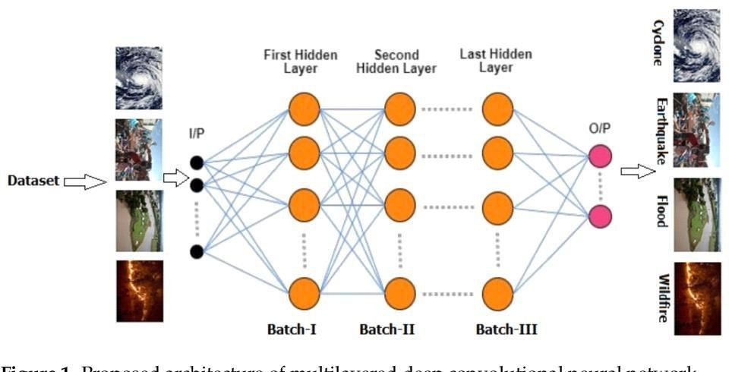

## Rainformer: Features Extraction Balanced Network for Radar-Based Precipitation Nowcasting

Precipitation nowcasting task is one of the basic challenges in meteorological research. It aims at predicting the rainfall intensity in the future 0–2 h by using specific meteorological information. It has an

enormous application range related with human beings. Precipitation nowcasting methods can be roughly divided into numerical weather prediction (NWP) and extrapolation-based methods. NWP relies on vast complex meteorological data as input data and requires an expensive computing resource. At this point, radar extrapolation-based methods may be a good choice. It does not need other meteorological information and only uses several radar maps/frames to predict future radar maps.

Convolutional long short-term memory (ConvLSTM) is the first ConvRNN-based method applied to the precipitation nowcasting field to the best of our knowledge. Due to the structure of long short-term memory (LSTM), the ConvRNN-based methods can memorize the past information and effectively capture the movement trend and rainfall intensity variation of rainfall. Although many prior works are superior to traditional algorithms, several issues remain.

A new framework for precipitation nowcasting named Rainformer is introduced. It can extract global and local features from radar echo maps separately, and fuses balanced these two features to enhance the model’s ability to predict heavy rain or rainstorm.

Rainformer consists of an encoder (green box) and decoder (blue box). They both have four stages. When the stage goes deeper, the feature size becomes smaller. Both encoder and decoder include FEBM. FEBM enhances the low to medium and high-intensity rainfall features at every stage.

## Natural Disasters Intensity Analysis and Classification Based on Multispectral ImagesUsing Multi-Layered Deep Convolutional Neural Network

Risk analysis is, in broad terms, a systematic process aimed at understanding the nature of risk in a given situation and expressing the risk together with the underlying knowledge base. The primary focus is

on artificial intelligence, machine learning, and statistical methods. The proposed model works in twoblocks: Block-I convolutional neural network (B-I CNN), for detection and occurrence of disasters,and BlockII convolutional neural network (B-II CNN), for classification of natural disaster inten‐sity types with different filters and parameters.

Natural hazards pose significant risks throughout the world. They are among the deadliest disasters. These events cause significant economic damage as well, with losses from a large tropical cyclone impacting a developed nation approaching or, at times, exceeding U.S. $100 billion.

## Tropical Cyclone Intensity Estimation Using Multidimensional Convolutional Neural Network From Multichannel Satellite Imagery

Tropical Cyclone is a severe storm that occurs over the tropical ocean. TC intensity is one of the key parameters for TC prediction and disaster prevention. Accurate estimation of TC intensity is important to theoretical research studies and practical applications. Inspired by the success of deep learning technology in various fields, recent attempts for TC intensity estimation focus on designing effective convolutional neural network (CNN).

We design a deep learning model, called 3DAttentionTCNet, which is inspired by AlexNet. Unlike Alexnet, as the pooling layer compresses some important information resulting in the loss of some intensity features, we remove the pooling layers. In addition, we remove the dropout layer, the reason why we make this adjustment is that dropout regularization technology randomly removes some neurons during the training process. It has been confirmed that removing the dropout layer will cause negative deviations.

## Designing Deep-Based Learning Flood Forecast Model With

**ConvLSTM Hybrid Algorithm**

Early detection of natural disasters such as floods can greatly assist humans in reducing the extent of the damage caused by such events. In the Fiji Islands, where this study is focused, recent flood events resulted in major damages amounting to millions of dollars. The loss of at least 225 lives during the 1931 flood event in Fiji was primarily due to the unavailability of efficient flood warning systems.

One simple, yet a robust mathematical tool used to determine the flood state at a particular time for a given area is the Flood Index (IF). A model is developed Develop multi-step predictive model using ConvLSTM, as an objective model, with alternative methods of LSTM, CNN-LSTM and SVR that can also determine the flood state.

## A Conformal Regressor With Random Forests for Tropical Cyclone Intensity Estimation

Tropical Cyclone is an intense vortex system that originates over the tropical ocean and is one of the most destructive natural disasters. TC intensity usually refers to the maximum wind speed near the TC center. TC intensity is an important indicator to quantify the destruction potential.

The basic idea of using satellite data to estimate the intensity is that the cloud pattern strongly correlates with the TC intensity in the image. It is considered an excellent way to extract features from satellite images to estimate TC intensity. The most common technique is the Dvorak technique. The Dvorak technique tried to estimate the TC intensity using visible or infrared images based on the cloud structure.

Various machine learning models have also been applied to TC intensity estimation. Among them, the most widely used was the linear

regression model. A multiple linear regression (MLR) model was constructed based on the extraction of the most significant signals and parameters from satellite infrared images.

**Conclusions** Manyresearchershaveattemptedtousedifferentdeeplearningmethodsfor detection of natural disasters. However, the detection of natural disasters by using deep learning techniques still faces various issues due to noise and serious class imbalance problems. To address these problems, we proposed a multilayered deep convolutional neural network for detection and intensity classification of natural disasters. The proposed method works in two blocks—one for detection of natural disaster occurrence and the second block is used to remove imbalanced class issues. The results were calculated as average statistical values: sensitivity, 97.54%; specificity, 98.22%; accuracy rate, 99.92%; precision, 97.79%; and F1-score, 97.97% for the proposed model. The proposed model achieved the highest accuracy as compared to other state-of-the-art methods due to its multilayered structure. The proposed model performs significantly better for natural disaster detection and classification, but in the future the model can be used for various natural disaster detection processes.

# References

* 1. Mignan, A.; Broccardo, M. Neural network applications in earthquake prediction (1994–2019): Meta-analytic and statistical insights on their limitations. Seism. Res. Lett. 2020, 91, 2330–2342. [CrossRef]
  2. Tonini,M.; D’Andrea,M.; Biondi,G.; DegliEsposti,S.; Trucchia,A.; Fiorucci,P.AMachineLearning-BasedApproachforWildfire Susceptibility

Mapping. The Case Study of the Liguria Region in Italy. Geosciences 2020, 10, 105. [CrossRef]

* 1. Islam, A.R.M.T.; Talukdar, S.; Mahato, S.; Kundu, S.; Eibek, K.U.; Pham, Q.B.; Kuriqi, A.; Linh, N.T.T. Flood susceptibility modelling using advanced ensemble machine learning models. Geosci. Front. 2021, 12, 101075. [CrossRef]
  2. Schlemper, J.; Caballero, J.; Hajnal, V.; Price, A.N.; Rueckert, D. A deep cascade of convolutional neural networks for dynamic MR image reconstruction. IEEE Trans. Med. Imaging 2017, 37, 491–503. [CrossRef] [PubMed]
  3. Tang, C.; Zhu, Q.; Wu, W.; Huang, W.; Hong, C.; Niu, X. PLANET: Improved convolutional neural networks with image enhancement for image classification. Math. Probl. Eng. 2020, 2020. [CrossRef]
  4. D. Han, L. Chan, and N. Zhu, ``Flood forecasting using support vector machines,''
  5. X. H. Le, H. V. Ho, G. Lee, and S. Jung, ``Application of longshort- term memory (LSTM) neural network for flood forecasting”
  6. M. F. Piñeros, E. A. Ritchie, and J. S. Tyo, “Estimating tropical cyclone intensity from infrared image data,”
  7. T. L. Olander and C. S. Velden, “Tropical cyclone convection and intensity analysis using differenced infrared and water vapor imagery”.
  8. X. Shi et al., “Deep learning for precipitation nowcasting: A benchmark and a new model,”

# 